Final Project

Lottery Imitation System (Web Application)

Unity Team:Nurseit Gulnaz,Zhuman Symbat,Meirambek Zhannur

Group:SE-2412

1. Project relevance (Why this topic was chosen)
The topic of the Lottery Imitation System was chosen because it combines several important aspects of modern web development: backend logic, frontend interaction, data persistence, and business rules. Lottery systems are a well-known real-world example of applications that require strict logic, correctness, and transparency. Even though this project does not involve real money, it simulates realistic processes such as user registration, ticket purchasing, draw execution, prize allocation, and statistics tracking.
From an educational perspective, this project is highly relevant because it allows the developer to practice building a full-stack web application using Go (Golang) on the backend and HTML/CSS/JavaScript on the frontend. The system demonstrates how different components (handlers, services, repositories, models) interact with each other in a layered architecture. This makes the project suitable for understanding clean code structure, separation of concerns, and maintainability.
Additionally, lottery-like mechanics are often used not only in gambling but also in marketing campaigns, educational platforms, and gamified systems. Therefore, the logic implemented in this project can be adapted to many other domains, which increases its practical value.

1.2 Analysis of competitors in Kazakhstan
In Kazakhstan, there are several well-known lottery-related platforms, such as KazLoto and other government-supported lottery services. These platforms focus on real-money lotteries and operate under strict legal regulations. Their main strengths are official authorization, large prize pools, and nationwide recognition.
However, such platforms are not aimed at education, experimentation, or learning purposes. They do not provide transparency in terms of internal logic, algorithms, or data processing, as their systems are closed-source and commercially oriented.
The proposed Lottery Imitation System does not aim to compete directly with real lottery services in terms of prize value or legal scope. Instead, its competitiveness lies in:
- Educational focus
- Transparency of logic
- Open and understandable structure
- Flexibility for further development
Unlike existing platforms, this system can be used as a learning tool, a demo project, or a prototype for similar applications. It can also be extended with analytics, probability simulations, or user behavior studies, which real platforms usually do not provide to the public.

1.3 Project auditory (Target audience)
The target audience of this project includes several groups:
- Students and beginner developers
The system is designed to be understandable and well-structured, making it suitable for students who are learning backend development, REST APIs, and web application architecture.
- Instructors and evaluators
Teachers and mentors can use this project as an example of a correctly organized web application with clear business logic and separation into layers (handlers, services, repositories).
- Developers interested in Go (Golang)
Since Go is widely used for backend systems, this project demonstrates how Go can be applied to build a complete web application without heavy frameworks.
- Educational institutions
The project can be adapted as a base for laboratory works, coursework, or further research into probability-based systems.

1.4 Project features (Functionality and design ideas)
The Lottery Imitation System includes several key features that make it functional and visually appealing:
- User authentication system
Users can register, log in, and log out. Each user has a balance that is updated based on ticket purchases and prizes.
- Ticket purchasing logic
Users can select exactly six unique numbers from a defined range and purchase tickets only when a draw is active.
- Draw management (Admin panel)
The administrator can manually create and execute draws. The system prevents multiple active draws at the same time, ensuring correct logic.
- Automatic prize calculation
After a draw is executed, the system automatically counts matches for each ticket and assigns prizes based on predefined rules (money, travel, gift).
- Prize transparency
Each prize is linked to both a ticket and a user, allowing the admin to see who won and what type of prize was awarded.
- Statistics and analytics
The admin panel displays statistics such as total users, total tickets, total draws, and prizes grouped by type.
- Modern UI design
The interface uses a clean layout with gradient backgrounds, cards, and interactive elements. The design can be themed (e.g., pink tones) to enhance user experience.
- No real money disclaimer
The system is clearly marked as an educational project, ensuring ethical and legal safety.
Use Case Diagram:
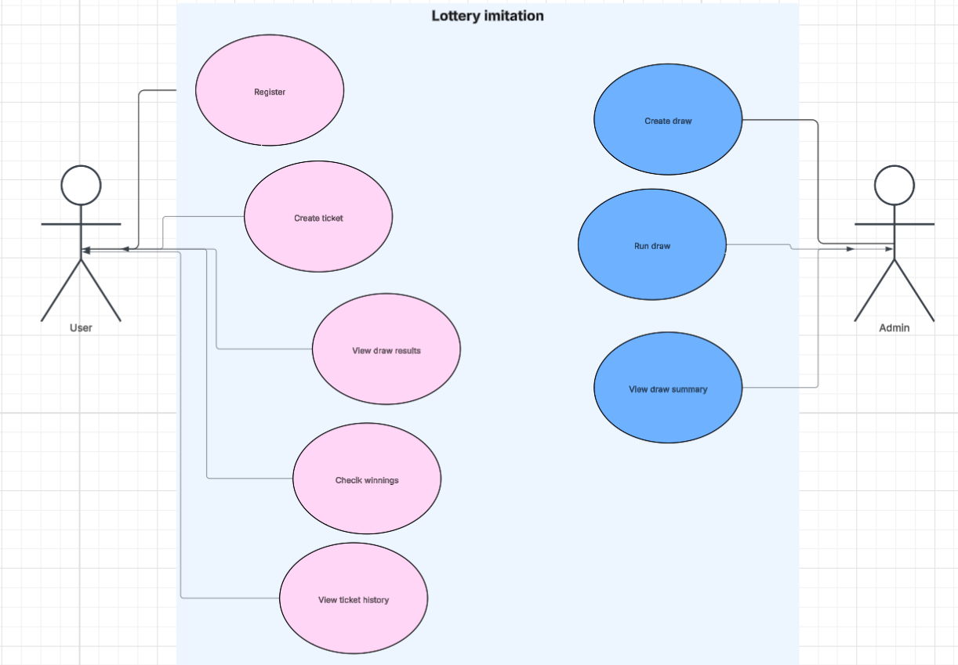
ERD (Entity-Relationship Diagram)
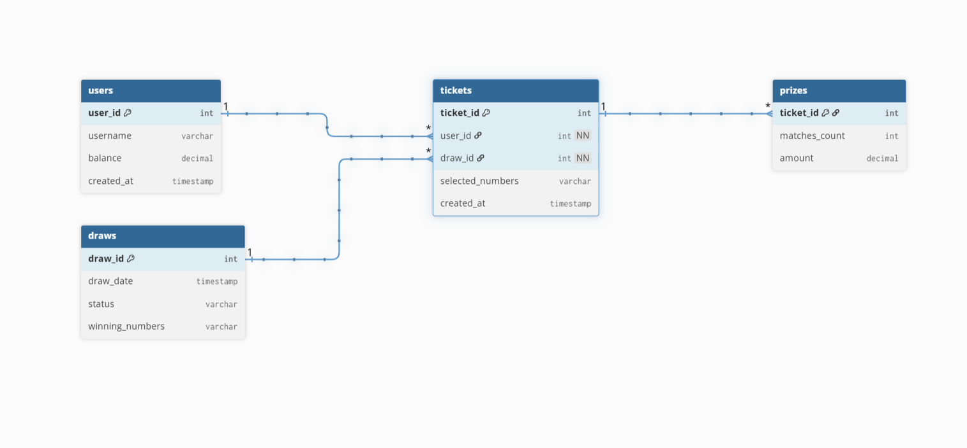

Uml Diagram
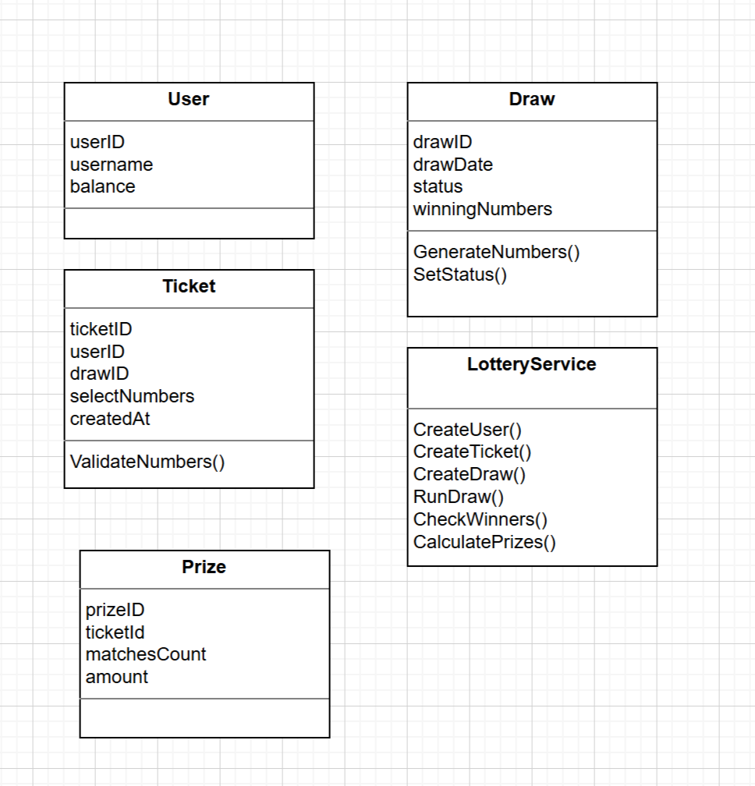

Project Plan by Weeks (Weeks 7–10)

Week 7 – Planning and Analysis
- Zhannur: Project proposal writing, project relevance description, UML Class Diagram, architecture consolidation.
- Gulnaz: Competitor analysis, planned features definition, ER Diagram design.
- Symbat: Target users definition, Use-Case Diagram creation, system architecture design.

Week 8 – Project Initialization and Core Setup
- Zhannur: Git repository creation, branch management.
- Gulnaz: Domain models definition, service layer skeleton implementation.
- Symbat: Go project initialization, main.go creation, handlers skeleton setup.

Week 9 – Implementation and Integration
- Zhannur: Storage and utilities skeleton development.
- Gulnaz: Service logic consistency review, prize and draw logic validation.
- Symbat: Handlers integration with services, API connection and testing.

Week 10 – Finalization and Presentation Preparation
- Zhannur: README preparation, documentation finalization.
- Gulnaz: Models and services consistency review, final testing.
- Symbat: Build verification, system testing, presentation readiness.

The project was fully completed by Week 10 and prepared for presentation during the 2-hour class session, as required.

Conclusion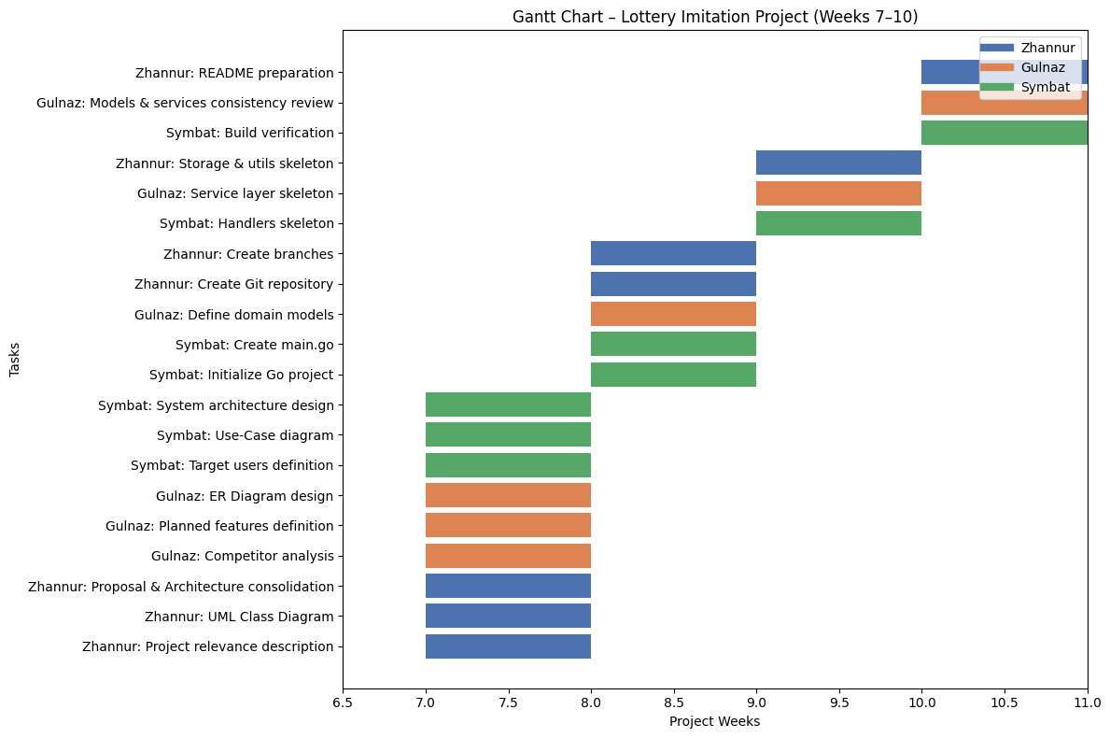

The Lottery Imitation System is a relevant, well-structured, and educational web application that demonstrates real-world backend logic in a safe and controlled environment. While inspired by existing lottery platforms in Kazakhstan, it focuses on transparency, learning, and extensibility rather than commercial competition. The project successfully combines technical depth with practical usability, making it suitable for academic evaluation and future development.

